**Amazon SNS**

Amazon Simple Notification Service

Case Study

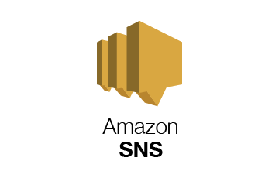

**Introduction**

Amazon Simple Notification Service (Amazon SNS) is a managed service that provides message delivery from publishers to subscribers (also known as producers and consumers). Publishers communicate asynchronously with subscribers by sending messages to a topic, which is a logical access point and communication channel. Clients can subscribe to the SNS topic and receive published messages using a supported endpoint type, such as Amazon Kinesis Data Firehose, Amazon SQS, AWS Lambda, HTTP, email, mobile push notifications, and mobile text messages (SMS).


            A publisher sends a message to an Amazon SNS topic, and subscribers receive the
                message.
        

**Sign into Amazon Management Console**

* Search Simple Notification service
* Click on it or open in new tab

This is dashboard of Amazon SNS

* Create Topic
* Give Topic Name
* Click on Next Step

Fill required Details

* Choose Standard Type
* Name
* Display name - optional

Keep other thing default

* If encrypted message required do it otherwise leave it
* Access policy keep method Basic
* Check other details if required change it otherwise keep it default
* Click on Create Topic

One message will pop up on screen that your topic is created

* See required details
* Click on Create Subscription

Fill details required for subscription

* Topic ARN
* Protocol – Email, AWS lambda, SMS, etc

* Write endpoint to it
* I Have chosen email that’s why I wrote my email ID
* Keep other option by default by now.
* Click on Create subscription

Your Subscription is created

And Mail sent to your email ID

Please check your Gmail

In Gmail you will see the one mail came from AWS notification.

* Click on that mail open it

Before opening that mail you can see the details of Subscription topic is in pending stage.

Now open mail

Click on confirm subscription

You will get this new tab open in browser automatically

In that Subscription confirmed !!! in there.

In SNS Service details you can see the status is now Confirmed

As shown in this tab

If you want to Unsubscribe this click on “click here to unsubscribe “ as shown in figure.

Subscription get removed.

Again, check in mail box that you unsubscribe is confirmed.

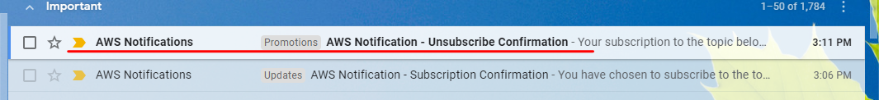

Open the mail

There is one more option to again resubscribe it

If you want to subscribe It you can do by just clicking it.

You can delete subscriptions you can delete it

* Select subscription and click on delete

* Click on Delete

**Mobile Messaging**

You can send notification by Mobile SMS .

* Click on Text messaging (SMS)
* Click on Publish text message

* Add a Phone Number
* Select message language

* Verify phone number
* You will get one verification code on you mobile phone write that number here
* And verify your number
* Its important to get your number verified then only you will get notified my AWS SNS.

* Write Message in Message box
* Select message type – Promotional
* Destination phone number

Keep other things by default

Click on Publish message

When you start using Amazon SNS to send SMS messages, your AWS account is in the *SMS sandbox*. The SMS sandbox provides a safe environment for you to try Amazon SNS features without risking your reputation as an SMS sender. While your account is in the SMS sandbox, you can use all of the features of Amazon SNS, with the following restrictions:

* You can send SMS messages only to verified destination phone numbers.
* You can have up to 10 verified destination phone numbers.
* You can delete destination phone numbers only after 24 or more hours have passed since verification or the last verification attempt.

Delete phone number

You can only delete phone number after 24 hours of verification.

But you can delete Topic

* Select topic that we have created
* Click on delete

Write delete me in dialogue box and click on delete.

